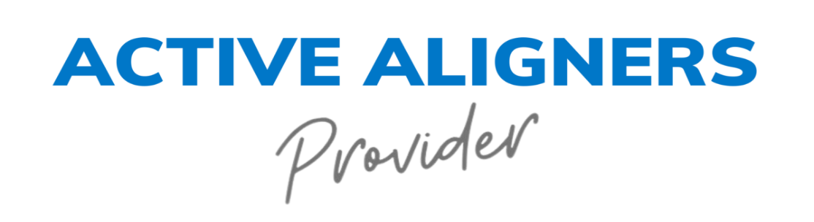

Release Authorization Form

Patient's Full Name: ____________________________________________
Date of Birth: ______________________
I, the undersigned patient, hereby authorize [Your Dental Practice Name] and its staff to use photographs, images, and any related materials (hereinafter collectively referred to as "Materials") of my dental treatment and results for the purpose of sharing on social media channels, websites, and promotional materials. This authorization is granted without any time restrictions and may be used as needed.
I understand and agree to the following terms and conditions:
- The purpose of sharing these Materials is for educational, promotional, and marketing purposes to showcase the services provided by [Your Dental Practice Name].
- I grant [Your Dental Practice Name] the right to use, reproduce, distribute, display, and publish the Materials, including my name and any testimonial I provide, in any media or format, including but not limited to social media platforms, websites, print materials, and other promotional outlets.
- I release [Your Dental Practice Name] and its employees from any claims, demands, or causes of action that I may have arising out of the use of the Materials as described in this authorization.
- I understand that the Materials may be viewed by the general public and may be shared and commented upon by other users on social media channels and websites.
- I have the right to revoke this authorization at any time by providing written notice to [Your Dental Practice Name]. Upon receiving this written notice, [Your Dental Practice Name] will cease using the Materials for the purposes described in this authorization. However, I understand that [Your Dental Practice Name] may have already used the Materials prior to my revocation.
By signing this Release Authorization Form, I acknowledge that I have read, understood, and agreed to the terms and conditions set forth herein. I am providing my consent voluntarily and without any coercion.
Patient's Signature: ___________________________ Date: ______________
Parent/Guardian Signature (if applicable): ___________________________
[If the patient is a minor or unable to provide consent]
Witness (Staff Member): ________________________ Date: ______________
[Your Dental Practice Name] [Address] [Phone Number] [Email Address]

Please retain a copy of this Release Authorization Form for your records.

